**Bamazon Customer**

Display List of Products:

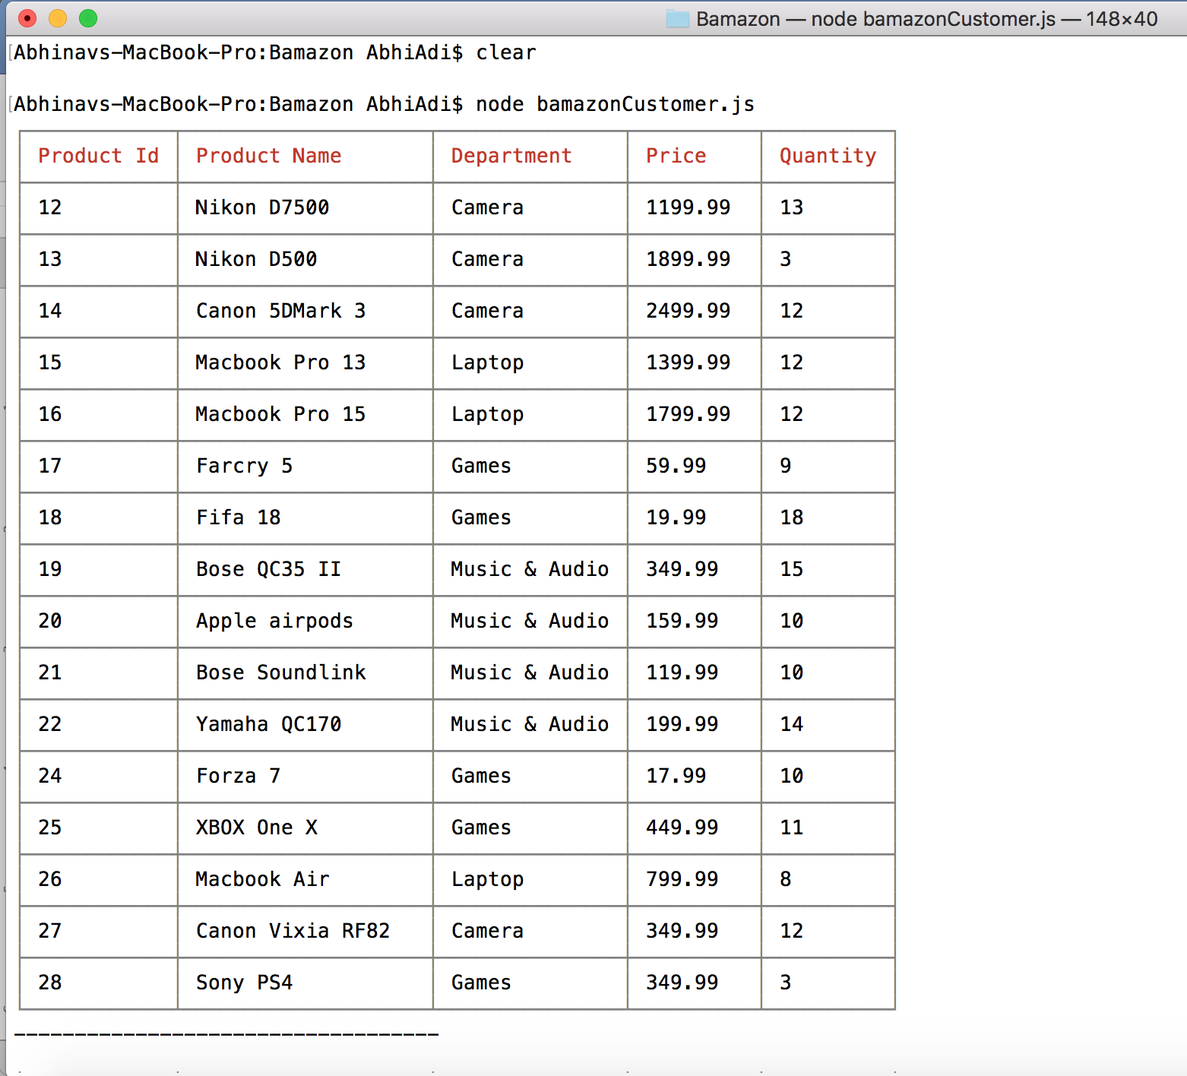

User input to purchase a product,

Product Purchased:

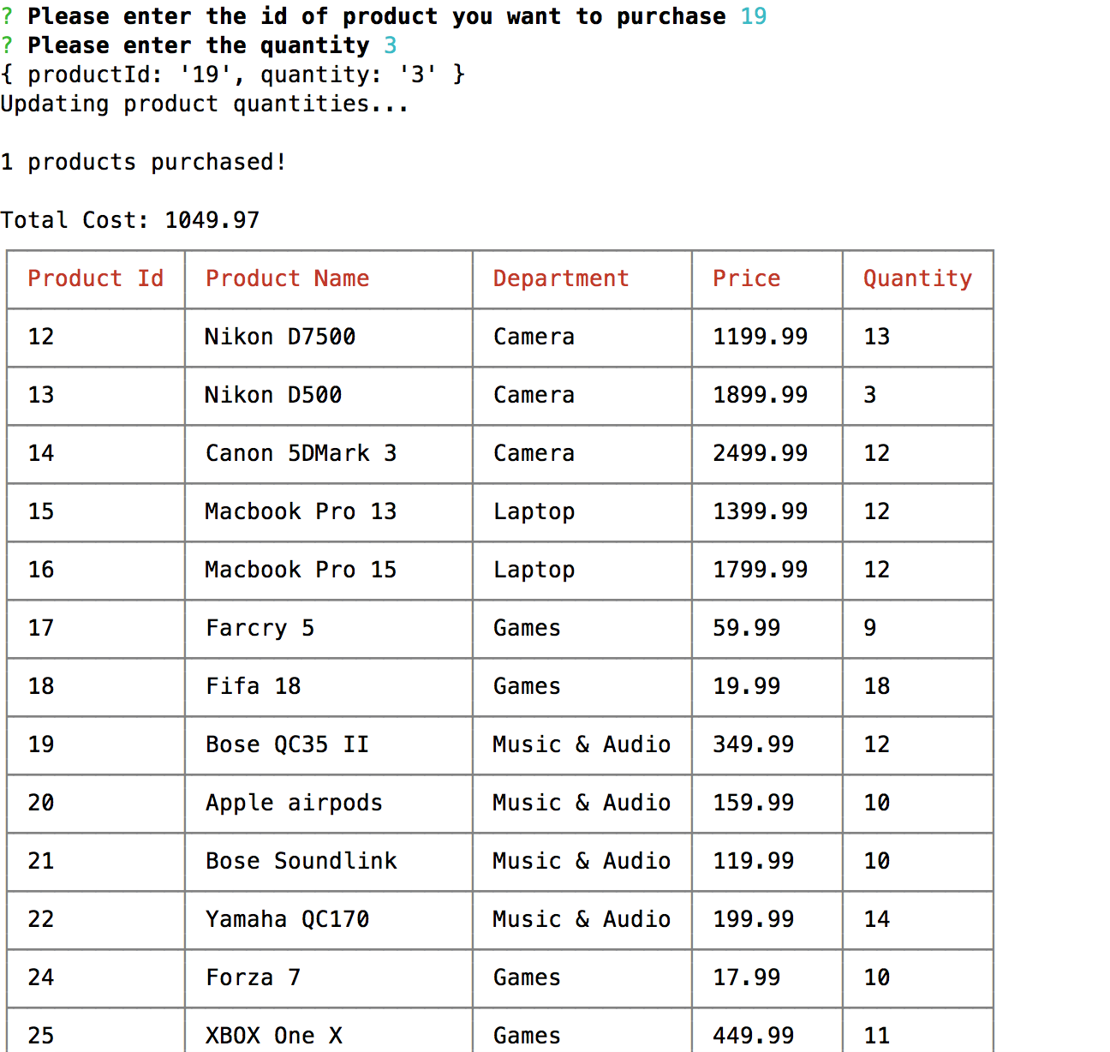

Database Updated:

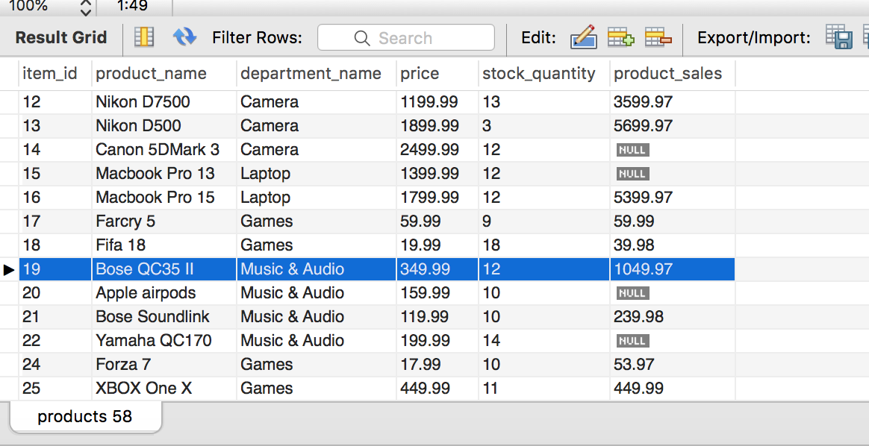

Purchase – Insufficient Quantity:

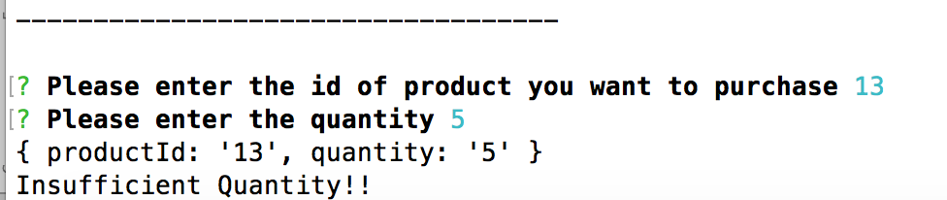

**Bamazon Manager:**

Display Menu Options:

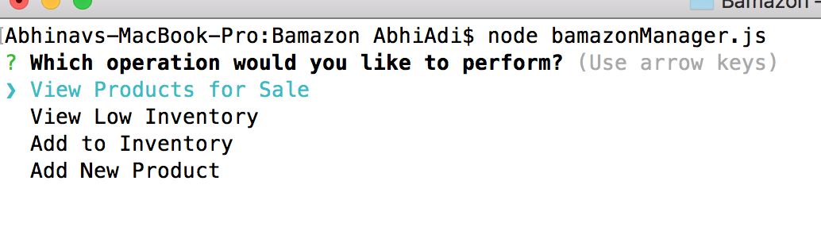

View Products for Sale:

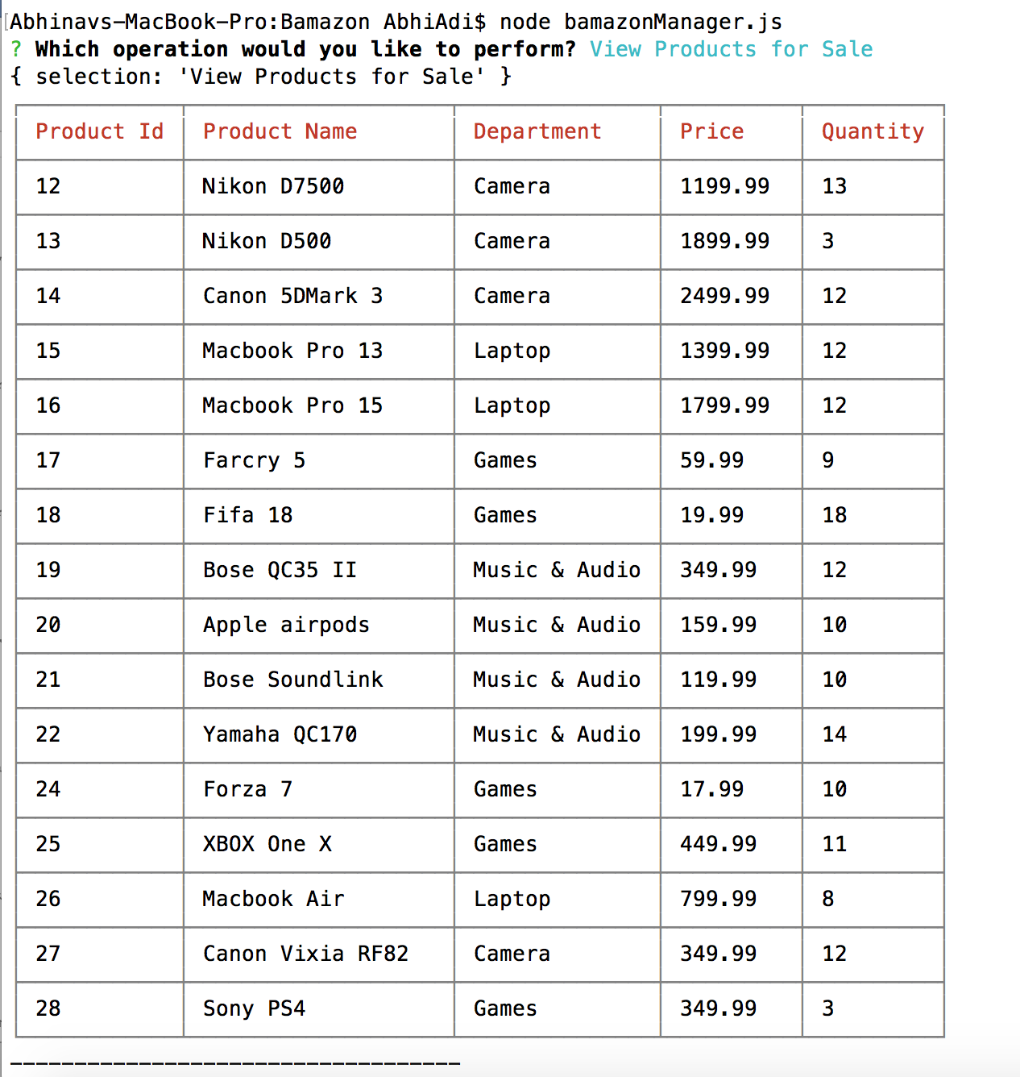

View Low Inventory:

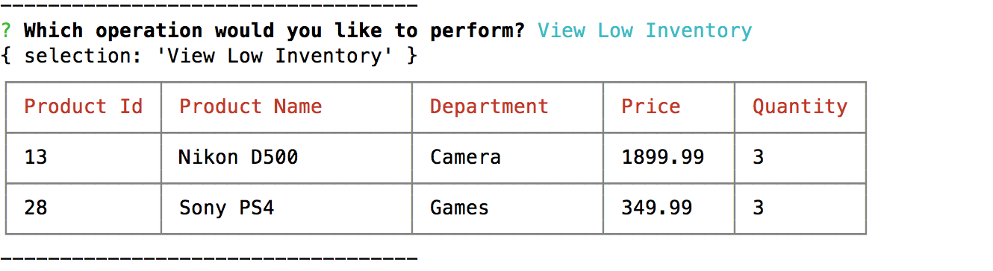

Add to Inventory:

User Input for Product Id and Quantity:

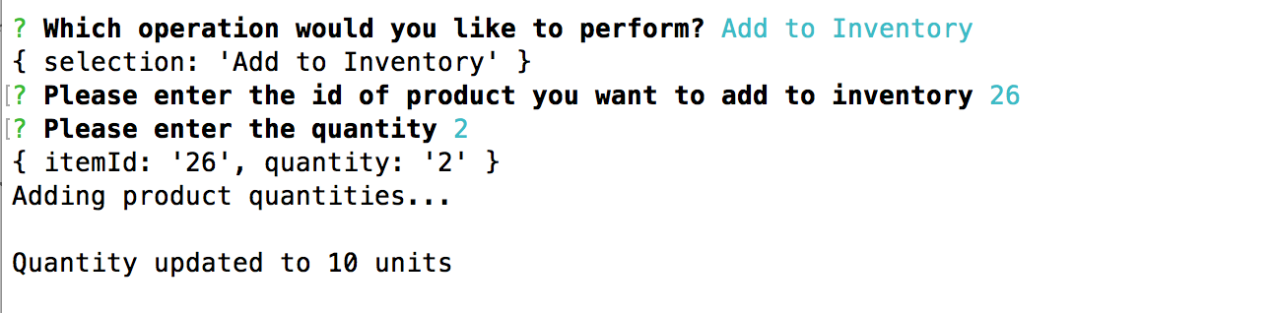

DB Updated:

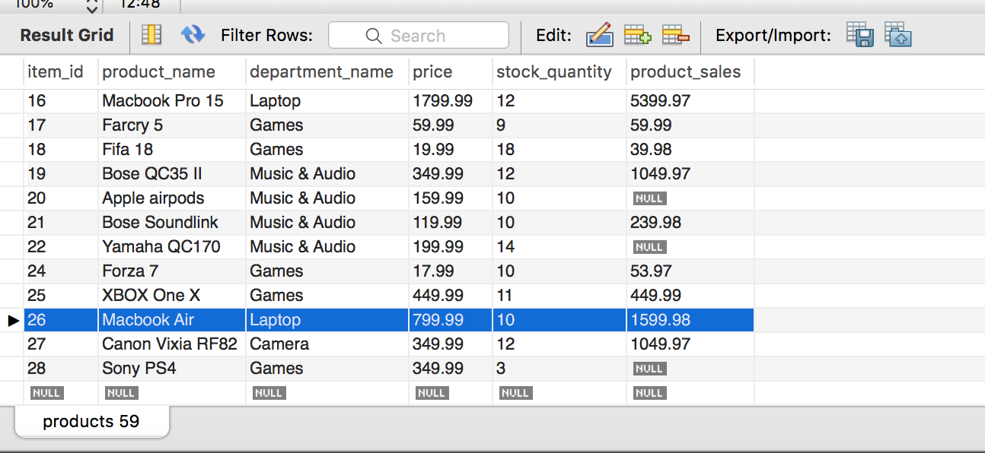

Add New Product:

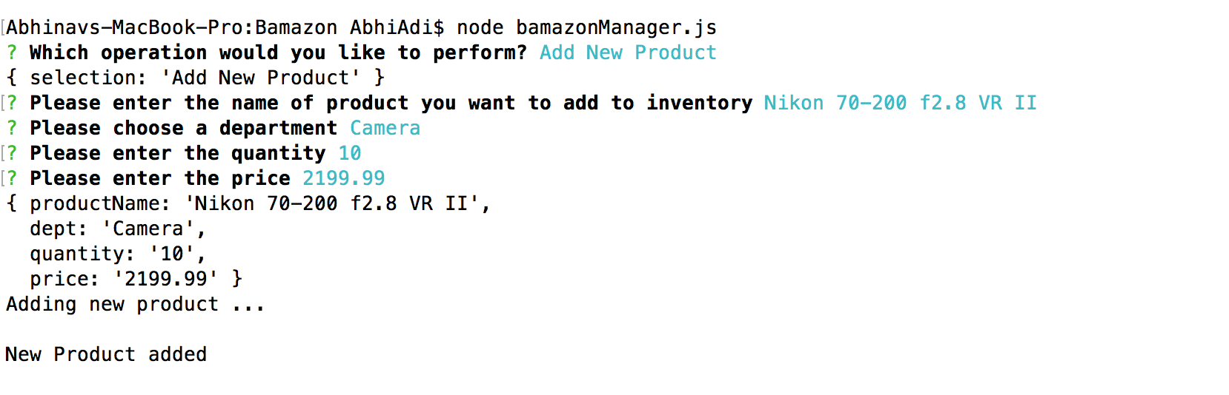

DB Updated:

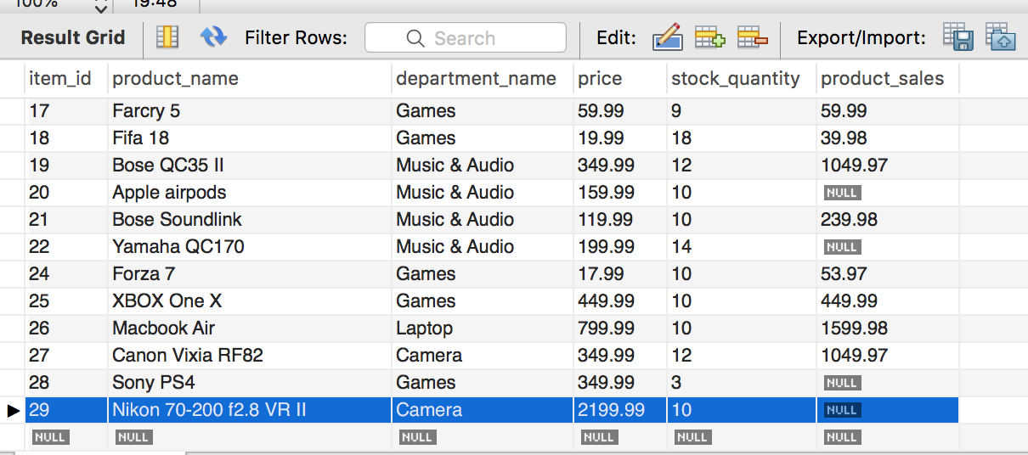

**Bamazon Supervisor:**

View Menu Options:

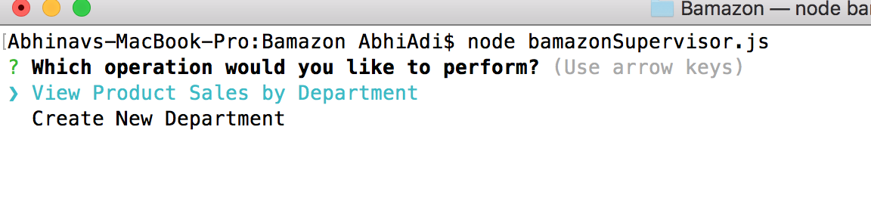

View Product Sales by Department:

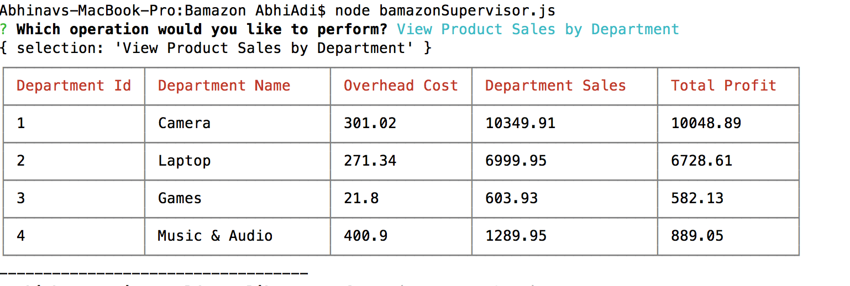

Add New Department:

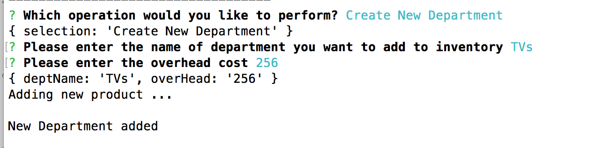

DB Updated:

